8.103: a) The wagon, after coming down the hill, will have speed 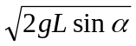 = 10 m/s. After the “collision”, the speed is 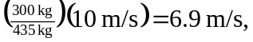and in the 5.0 s, the wagon will not reach the edge. b) The “collision” is completely inelastic, and kinetic energy is not conserved. The change in kinetic energy is so about 4800 J is lost.

